**Phase 2: -**

In this Phase I have chosen the following in my project  
  
• Company Profile Setup

• Business Hours & Holidays

• Fiscal Year Settings

• User Setup & Licenses

• Profiles

• Roles

• Permission Sets

• OWD

• Login Access Policies  
  
  
  
**Project:** Smart Internship & Placement Management System

**1. Company Profile**

* **Description:** The company profile defines the **organization-wide details** such as name, currency, time zone, and fiscal year. Updating these ensures that all system activities (business hours, reports, currency fields, etc.) align with your project’s identity and regional settings.  
    
    
  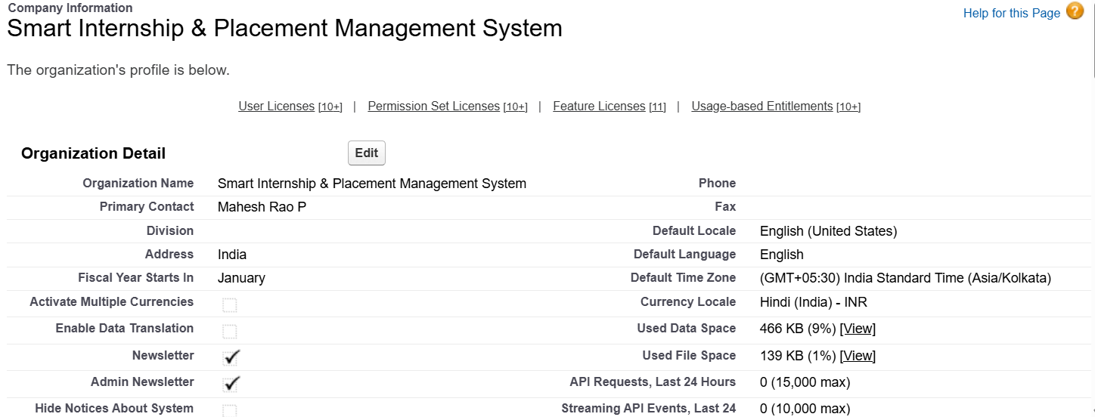

**2. Business Hours**

* **Description:** Business hours define the **working schedule** of the organization. This helps in managing response times, SLAs (Service Level Agreements), and availability tracking. For this project, business hours are set to reflect internship operations from **Monday–Saturday, 9:00 AM–6:00 PM IST**.  
    
    
  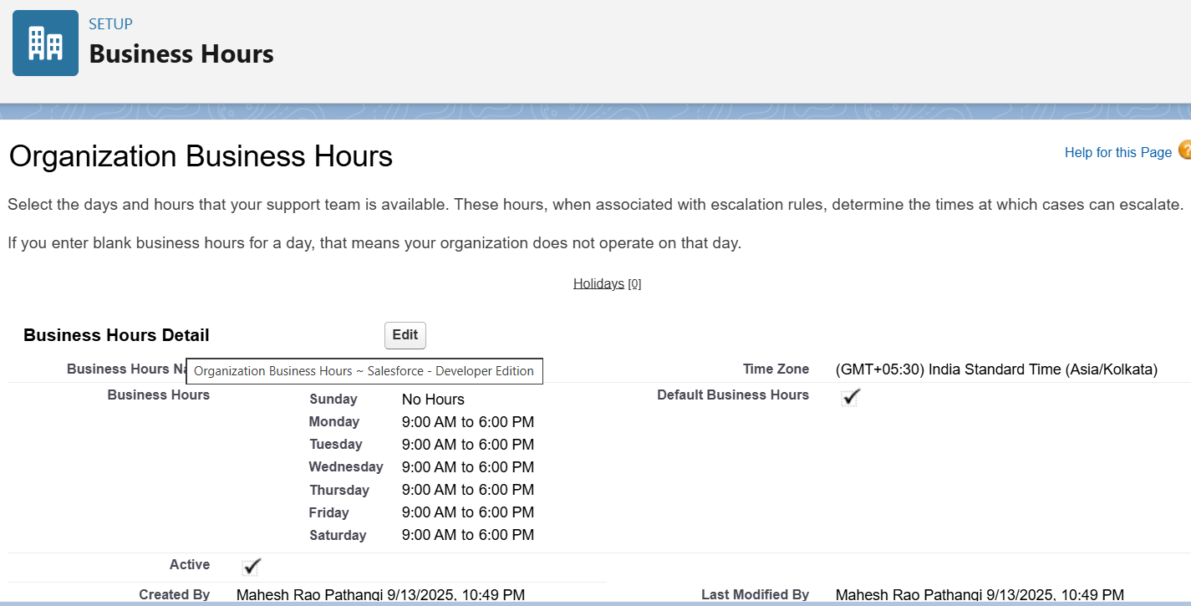

**3. Holidays (Optional)**

* **Description:** Holidays allow Salesforce to **exclude specific days** (like Independence Day, 15-Aug) from business operations. This ensures that workflows, escalations, and time-dependent activities don’t trigger on non-working days.  
    
  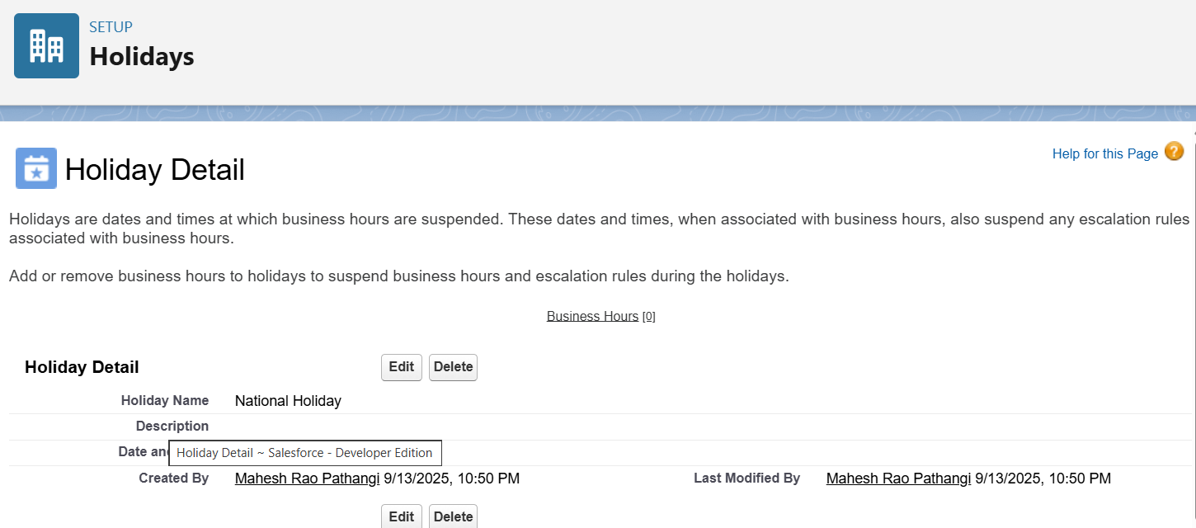

**4. Create User: Placement Officer**

* **Description:** This user represents the **Placement Officer** in the system, who oversees internship postings, manages company relations, and reviews student applications. A **System Administrator profile** is assigned so they can configure and monitor the platform.  
    
  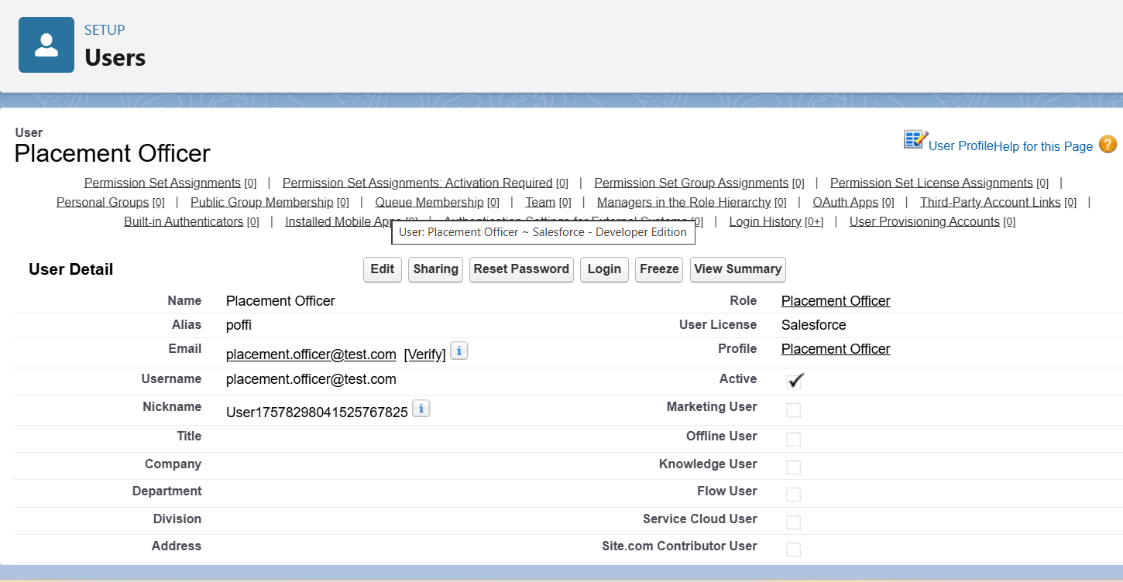

**5. Create User: Company HR**

* **Description:** The **Company HR user** is responsible for posting internship/job opportunities and reviewing student applications. A **Standard User profile** is provided with an HR-specific role to limit access only to relevant data.  
    
  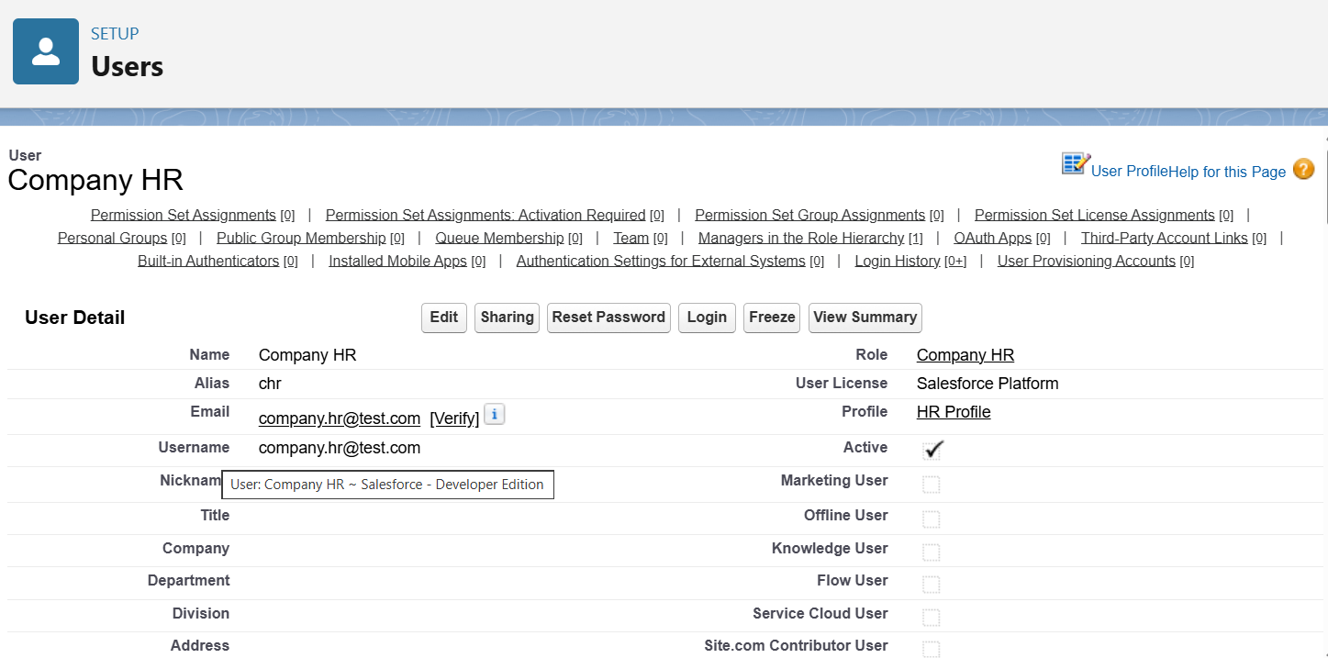

**6. Create User: Student**

* **Description:** The **Student user** represents candidates applying for internships. They are given limited access (via Standard User + Permission Set) to view opportunities, apply, and give feedback, but not manage system-wide settings.  
    
  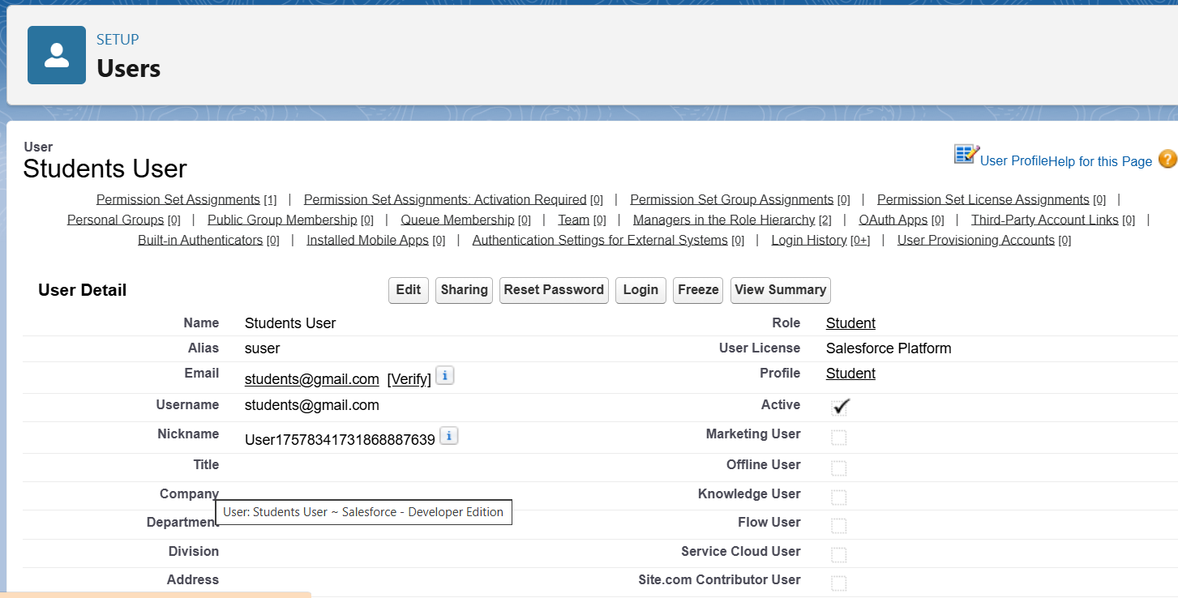

**7. Create Roles**

* **Description:** Roles define the **hierarchy of data visibility** in Salesforce. Placement Officer is at the top, followed by Company HR, then Student. This ensures:
  + Placement Officer can see everything
  + HR can see their company data + student applications  
      
    Students see only their own records  
      
    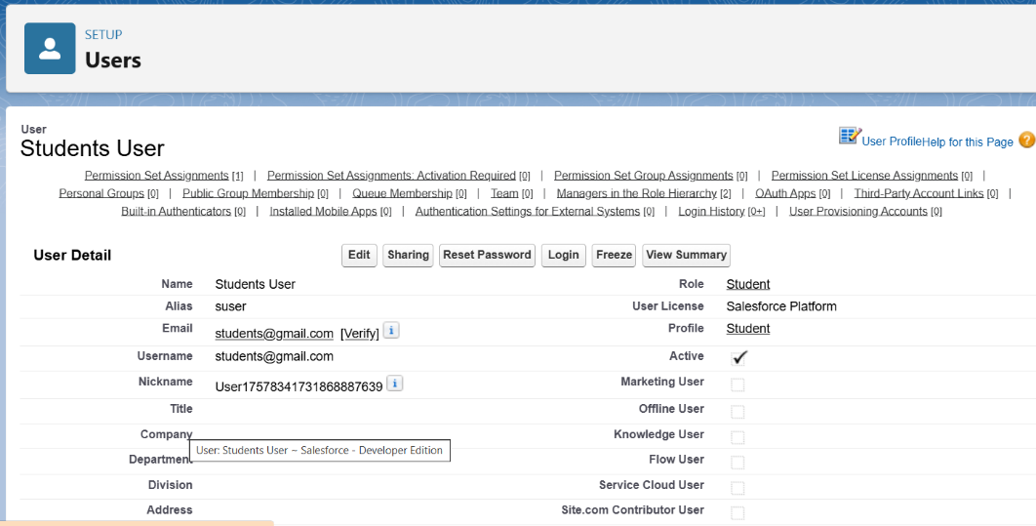

Before Creating Profiles, I have already started the phase 3 in which I Created a custom object which are necessary for My project. The following are the custom Objects I have created : -  
1. Student__c  
2. Company__c  
3. Internship__c  
4. Application__c  
5. Feedback__c

**8. Profiles**

* **Description:** Profiles control **object-level and field-level permissions**.
  + Placement Officer → System Administrator (full access)
  + Student → Standard User (restricted access)
  + Company HR → Custom profile cloned from Standard User with added permissions on Company, Internship, and Application objects.  
      
    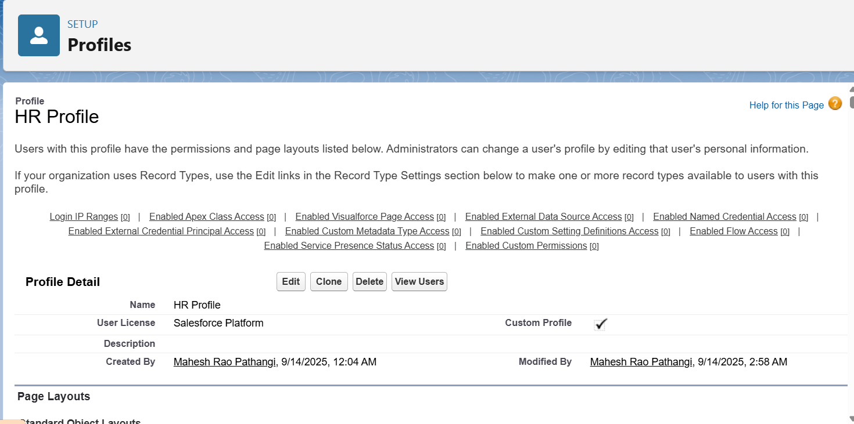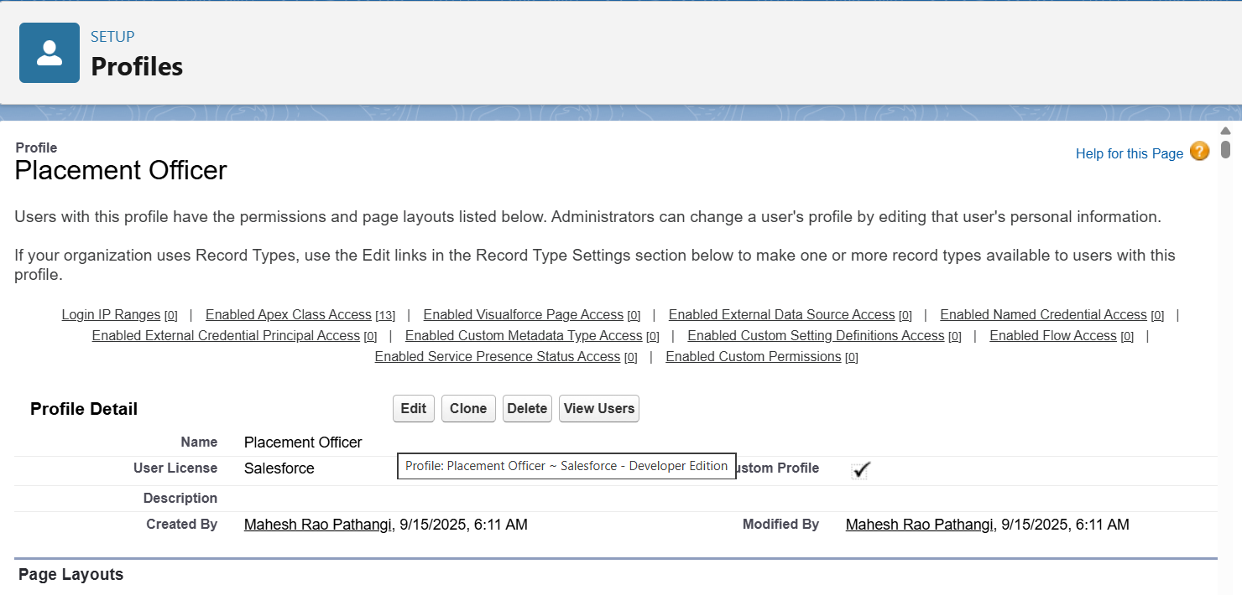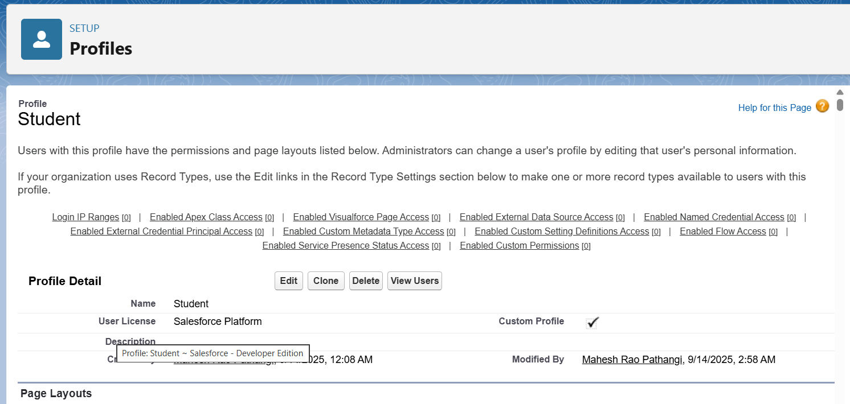

**9. Permission Set (Student_Access)**

* **Description:** Permission Sets allow giving **extra access** without changing profiles. Here, *Student_Access* enables students to create and manage their own applications, view internships, and submit feedback.  
    
  Application (Read/Write), Feedback (Read/Write), Internship (Read), Company (Read), Student (Read/Edit Own)  
    
    
    
    
  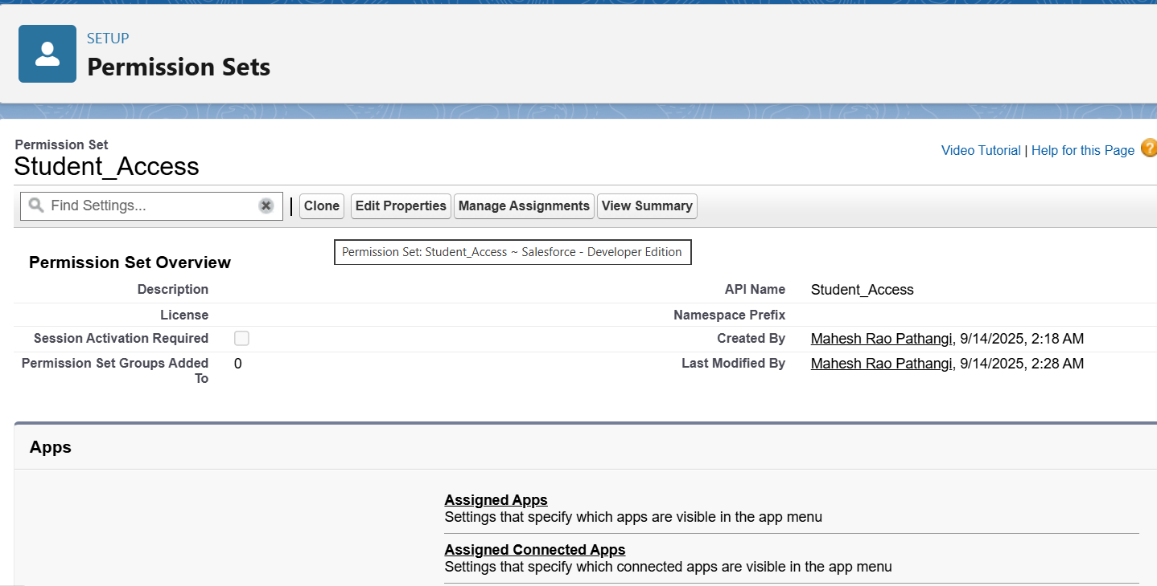

**10. Assign Permission Set**

* **Description:** The Student_Access Permission Set is **assigned to the Student user** to provide additional privileges beyond the Standard User profile. This ensures flexibility without needing multiple custom profiles.  
    
  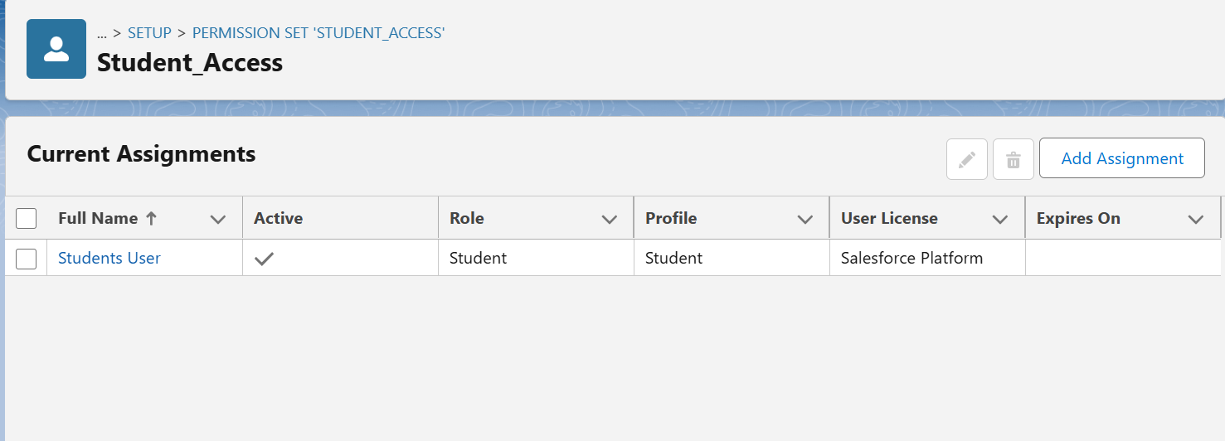

**11. OWD (Organization-Wide Defaults)**

* **Description:** OWD defines the **baseline security model** for data.
  + Student & Application → Private (students only see their own)
  + Company & Internship → Public Read Only (all can view, only owners/editors can modify)
  + Feedback → Private (only creator and Placement Officer can view)  
    This ensures data confidentiality and compliance with role hierarchy.  
      
    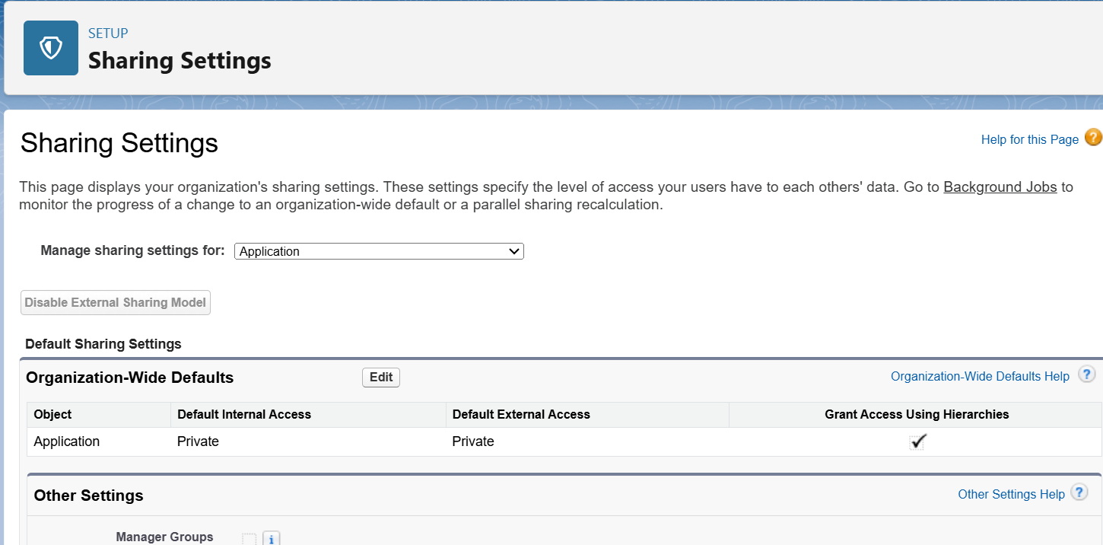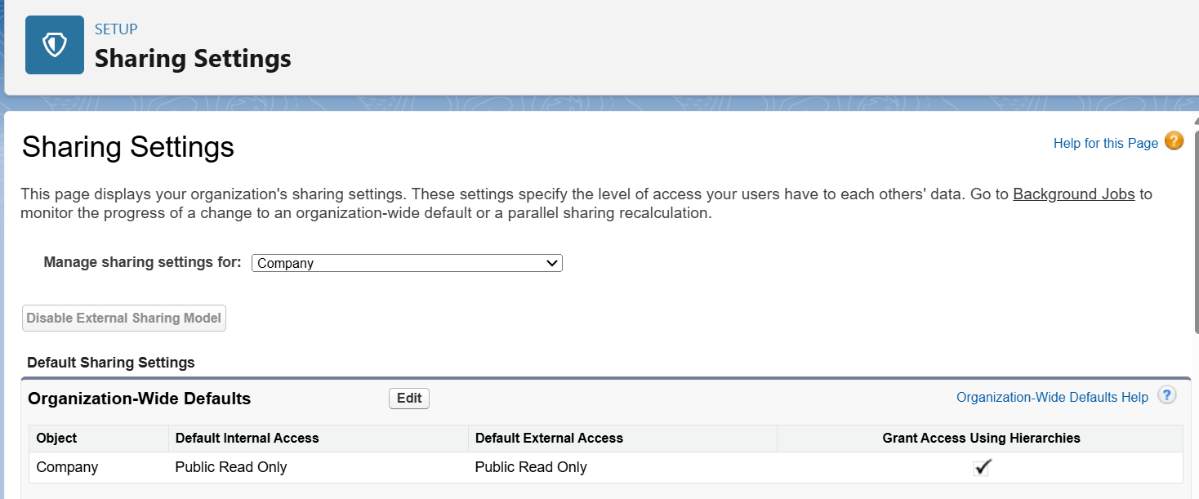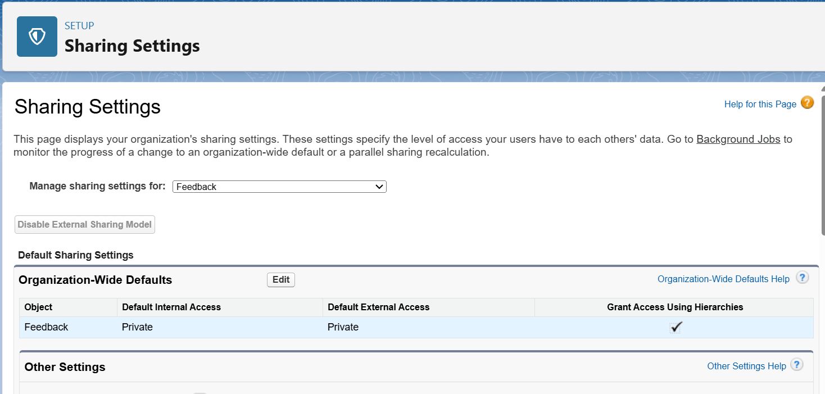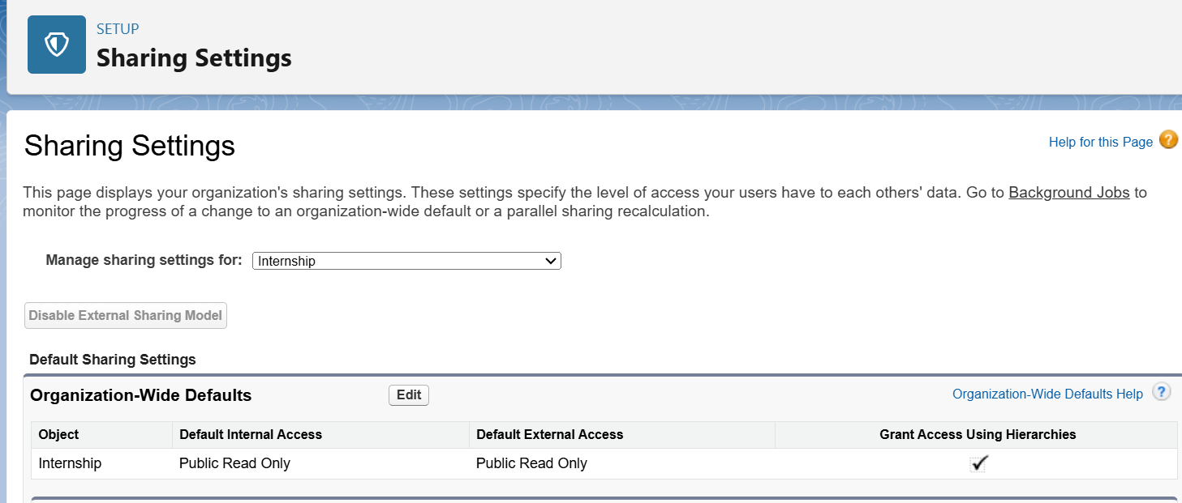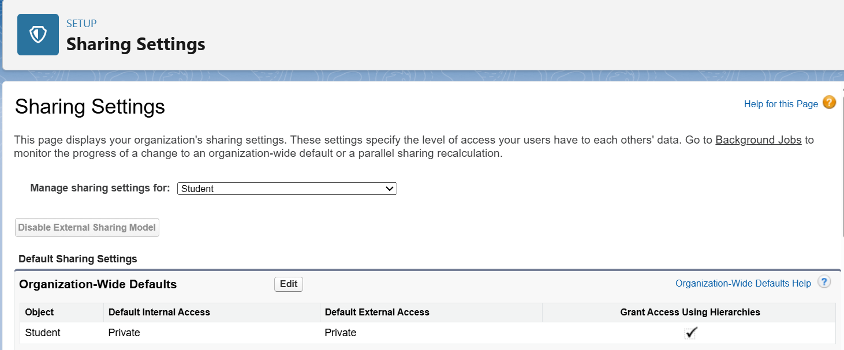

**13. Login Access Policies**

* **Description:** Enabling login access policies allows **admins to log in as any user** (Placement Officer, HR, or Student) for testing. This is crucial for validating role-based permissions and debugging issues.

